 

|  |
| --- |
| **FPT- APTECH COMPUTER EDUCATION** |
| eProject Report |
| Environment Survey |
|  |
| |  |  | | --- | --- | | **<Group Name>** | | | **Group Member** | Mai Thành Vinh - Student1240258>< >  Vũ Minh Tuấn - Student1245786>< >  Hoàng Thái Dương - Student1236296>< >  Cao Vương Bách - Student1245796>< >  Lê Thanh Tùng - Student1234237<> | | **Batch** | T1911E | | **Center** | <Center code> | | **Semester** | 3 | |
|  |

|  |
| --- |
| - Hanoi, 08 /2021 - |

**Contents**

1. Acknowledgements 4

2. Introduction 4

3. Problem Definition 4

3.1. Problem Abstraction 4

3.2. The Current System 4

3.3. The Proposed System 4

3.4. Boundaries of the System 4

3.5. Development Environment 4

4. Requirements and Business Flows 5

4.1. Customer Requirements 5

4.2. Activity Diagram(Optional) 5

4.3. Use Case Diagram 5

4.4. Use Case Specification (optional) 5

4.5. Other Concerns<Optional> 6

5. Design 7

5.1. System Architecture 7

5.2. Class Diagram 7

5.3. Class Diagram Explanation 7

5.4. Sequence Diagram 7

5.5. Collaboration Diagram (Optional) 7

5.6. State Diagram (Optional) 7

5.7. Entity Relationship Diagram 7

5.8. Database Design 7

5.9. Algorithms (optional) 8

5.10. Others (optional) 8

6. System Prototype 9

6. Management and Project Planning 10

6.1. Management Approach 10

6.2. Project Plan 10

6.3. Task Sheet 10

6.4. Meeting Minutes (Optional) 10

7. Checklists 11

7.1. Check List of Validation 11

7.2. Submission Checklist 11

8. Screenshots 11

9. Coding Convention 11

10. User Guide 12

11. Other Concerns<Optional> 13

Appendix 14

Glossary [Optional] 14

References [Optional] 14

Others<Optional> 14

# Acknowledgements

# Introduction

# Problem Definition

## Problem Abstraction

Our client is the educational institute, which wants to enlighten the students of that institute with the precautionary measures related to the environmental protection. So they conduct several seminars, lectures, etc. to the students. They now want to implement some tasks so that the attention of the young generation will be attracted towards taking necessary steps for taking care of the environment, as it relates to the health of the public. They started providing the seminars for free, for the students of the institute and encouraging the students to provide and interactive seminar sessions by visiting to some locations. Also they have started conducting surveys through papers and used to distribute the prizes for the first three students based on the marks secured in the survey and also based on the effective participation in visiting to locations for provided interactive sessions regarding the precautionary measures in protecting the environment. They wanted to reduce the paper consumption for conducting the surveys and want to provide a survey portal where the surveys will be held. So they have approached us to help them in building the survey portal for them.

## The Current System

At the time we received the customer's request, the educational institute was still using paper survey forms.

## The Proposed System

We propose to use a web application system for survey implementation as well as a place to promote the center's image.

## Boundaries of the System

*< List the scope\boundaries of the System-under-developed. This can be paraphrase from the Customer’s Requirement Statement sent from India>*

## Development Environment

We program in C# environment, the framework used is .net core 3.1 with entity framework, the database management system used are Microsoft sql for development environment and MySql for product environment.

# Requirements and Business Flows

*<In this section you will provide the requirements you developed against. This section should be useful, so only provide enough information (requirements, diagrams) to help with the implementation of the software. Focus on the “non-obvious” aspects. If you are dealing with a business process, activity diagrams are good. Making a set of requirements that is compact, simple and covers all the key aspects of the software can. Don’t do the work if you don’t need it!>*

## Customer Requirements

1. The website should perform three different functionalities.

Admin

Faculty or Staff

Students

2. The website should have the menu which should contain the following links

Home Page

Login / Register

Survey Board (Lists the survey and the competition details)

Edit Profile

Support FAQ s

1. Through login section and registering section, one should be able to either register online or login through the Account user id and password.
2. Through the username and password specified, the website should be able to judge or recognize the type of user functionality (Admin, or Faculty or Staff or Student), and the corresponding website functionality should be opened, so that the admin can access only the admin section, the faculty or staff can access the faulty or staff section, etc.
3. Once registered the admin will have the right to accept or decline the request for the registration. One can login through the website only when the registration is accepted by the admin.
4. Also the admin will have the right for deleting the username and the password (It will be applicable only when the student or staff or the faculty resigns from their respective duties)
5. While registering it should ask the following

Name



Roll No. or Employee Number (It is required because the survey panel is only for the students, faculty and the staff of the institution)

Class

Specification

Section

 Admission Date (For students) or Date of Joining (For faculty and staff) 8. Like the Admin will have the following functionalities

Place new survey for the faculty or staff

Place new survey for the students.

Delete survey

Accept or decline the registration request (Here the admin will check whether the person who registered belongs to the institution

Delete the User (where the details of the person who resigned from the duties provided by the institution will be deleted and he cannot have the right to access the website from then)

Place a competition, or list the names of the members who have won the prize for the previous surveys.

Enter new FAQ s

Edit FAQ s

Edit Support Information

1. On the home page of the website it should also include the details of the competitions that are to be held. Also the new surveys should be displayed in

a brief and a link to participate in the survey.

Note: Those who have logged into the website can only participate in the survey others cannot participate.

1. On the home page the new surveys that are to be conducted and the total surveys took place for the faculty or staff or for the student till date, and the number of surveys participated by the respective users (faculty or staff and the students), should be recorded.
2. On the Support Page the contact details, if any technical help, required in the participation of survey has to be displayed.
3. On the FAQ s Page the following details are to be included

How to register for the survey? How to participate in the survey?

How will I be intimated with the new survey?

What if it gives error, after participating in the entire survey, and clicked on the submit button at the last for submitting the survey?

Why I am unable to participate in the survey? (Two reasons : 1.Not the registered user, and 2.Technical Problem)

Why my registration request is not accepted?

Will there be any benefit if participated in the survey? How to participate in the competitions?

What if there are some arrears in participating the survey?

1. For the faculty or staff and the student login sections, on the menu there should be another link called Effective Participation , through which one can mention the survey details in detail like what are the seminars conducted by the user, the location at which the seminar is conducted, number of participants, etc.

## Activity Diagram

## Use Case Diagram

## Use Case Specification (optional)

## Other Concerns<Optional>

# Design

## System Architecture

*We use object-oriented architecture and layer architecture for business processing.*

## Class Diagram

## Class Diagram Explanation

The system has 3 class objects representation for 3 group users accessing into sites.

Admin is the user with the highest access, controls most of the web pages, contains executable functions that affect other classes such as, manages Seminar, Survey, Subject...

Both admin and 2 normal user groups, student and faculty, have to implement the Authentication class before they can login to the system.

Base entity class is a general class that contains information about tracking, operation time, creating or changing data.

## Sequence Diagram (Optional)

## Collaboration Diagram (Optional)

*<for important and complex interactions, collaboration diagrams should be drawn for clearing the details and supporting the system implementation. This section is optional>*

## State Diagram (Optional)

*<put all state diagrams here>*

## Entity Relationship Diagram

*<Provide the ERD Diagram for the system here. If your team uses file or in-memory storage facility instead of database, replace this section by ‘Data Structures’>*

## Database Design

## Algorithms (optional)

*<Provide the detailed description about algorithms used in the system. You can use Flow Chart or Activity Diagram to represent algorithms. Focus on the important and complex algorithms>*

## Others (optional)

*<Any design concerns or diagrams can be put here>*

# System Prototype

1. Homepage

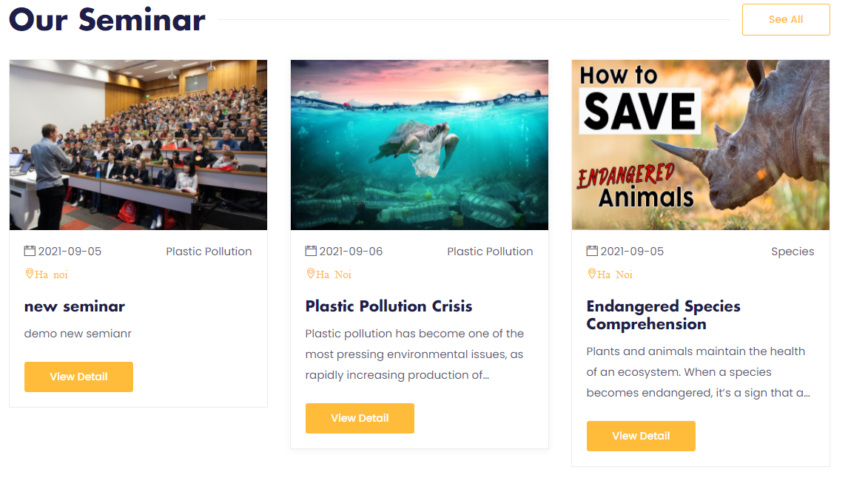



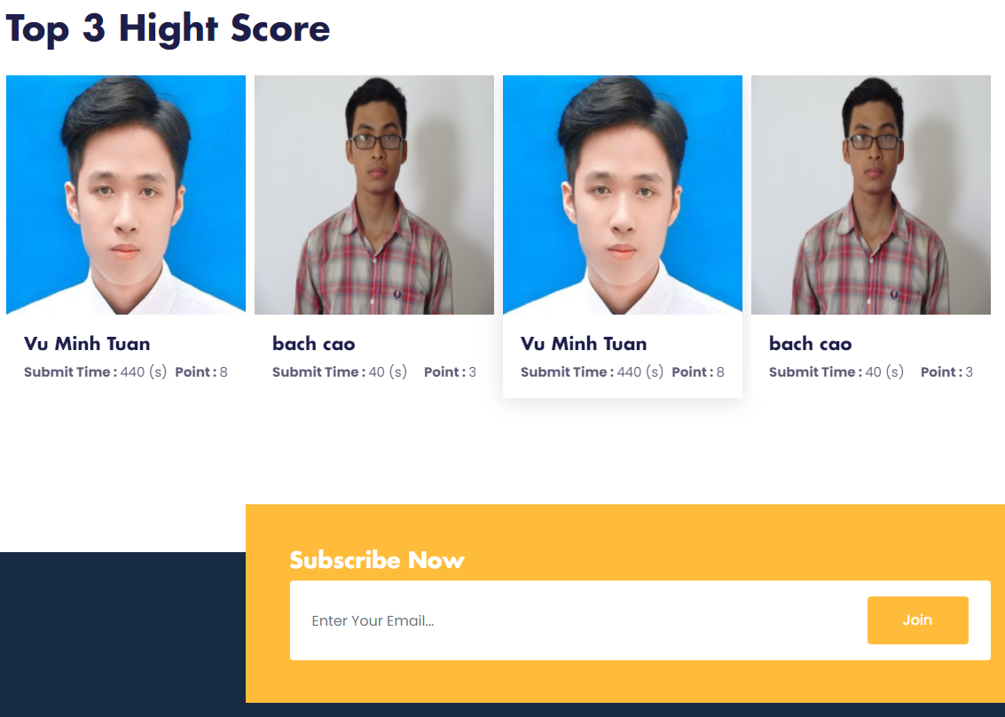

1. Registration

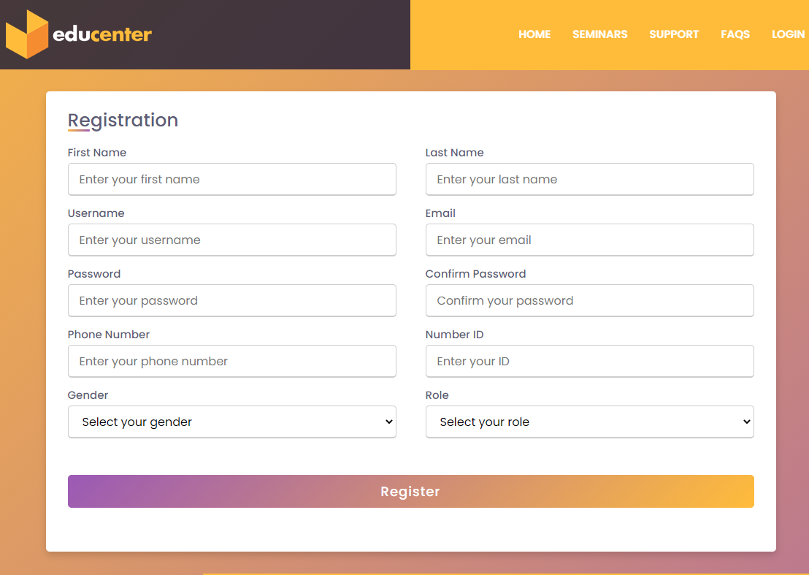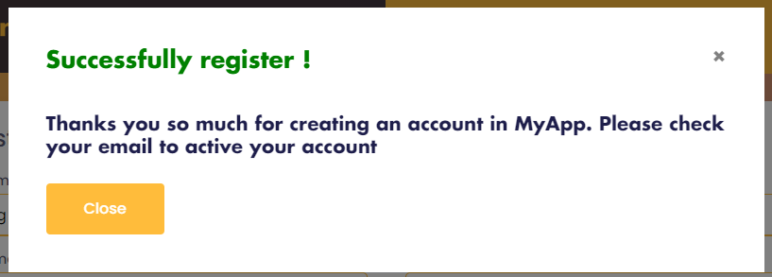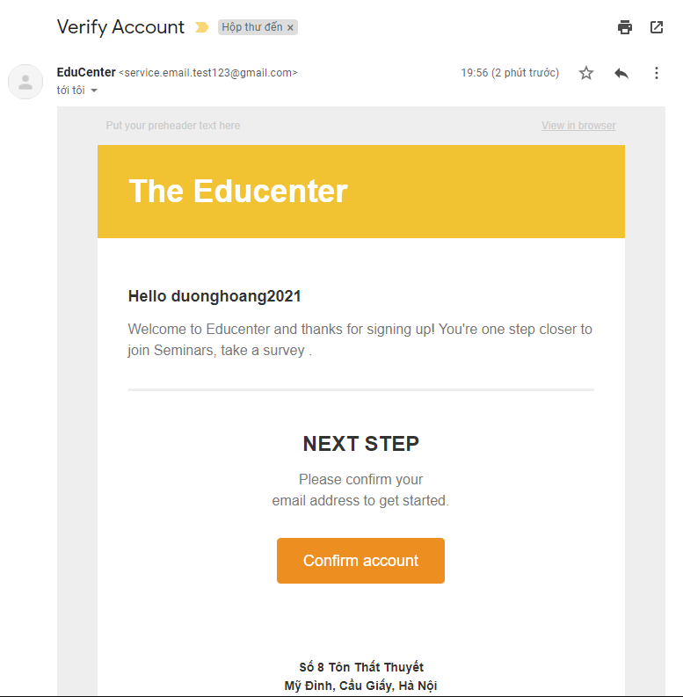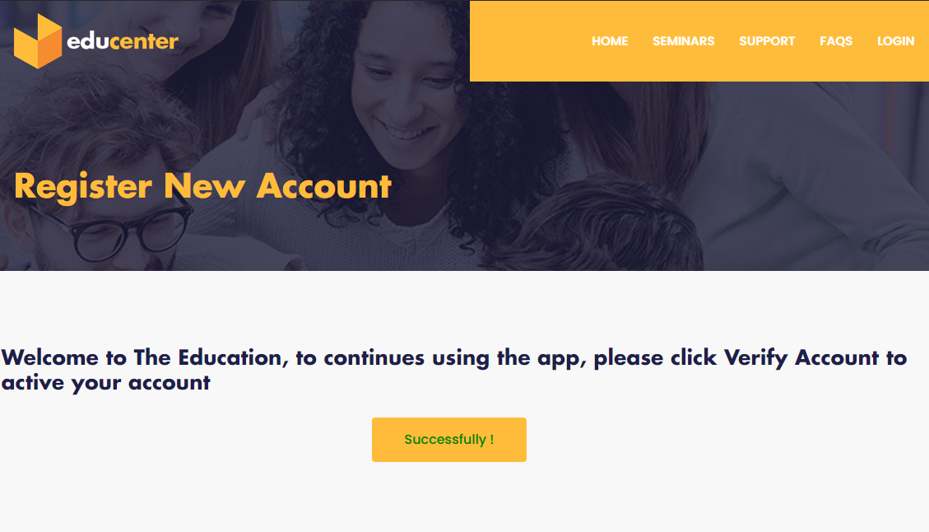

1. 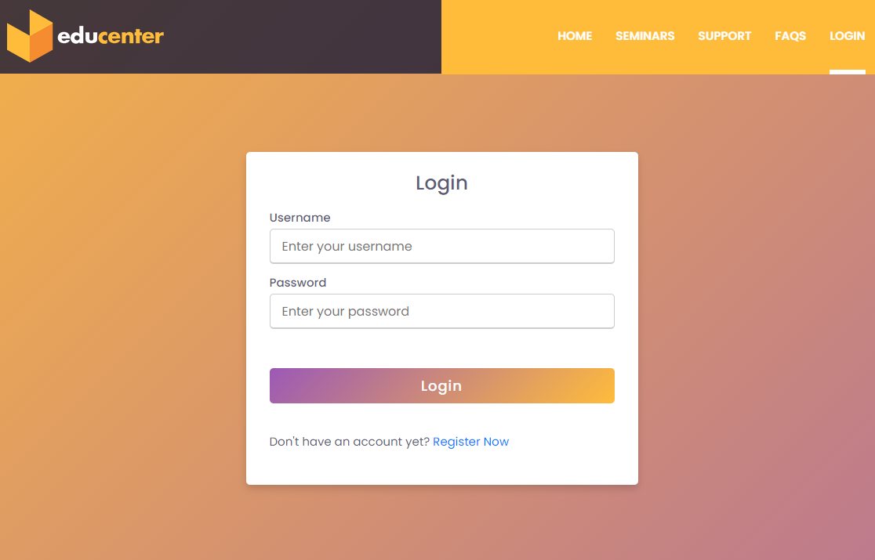Login
2. 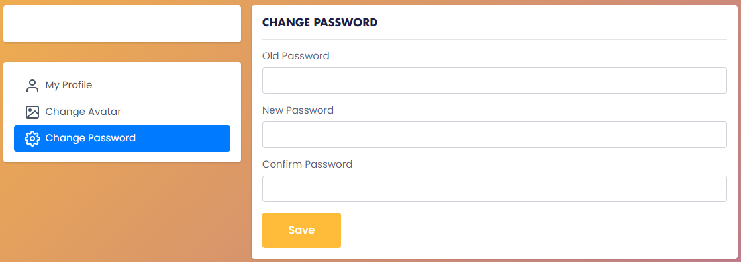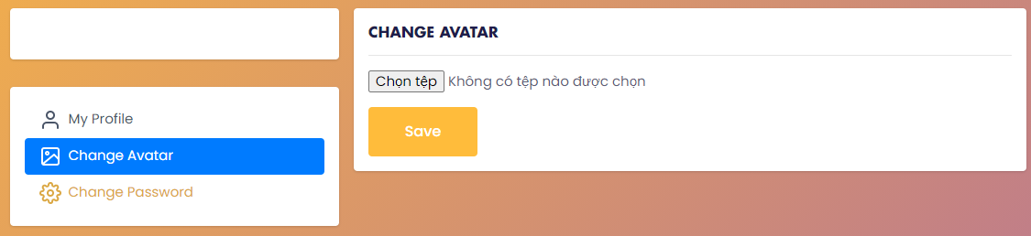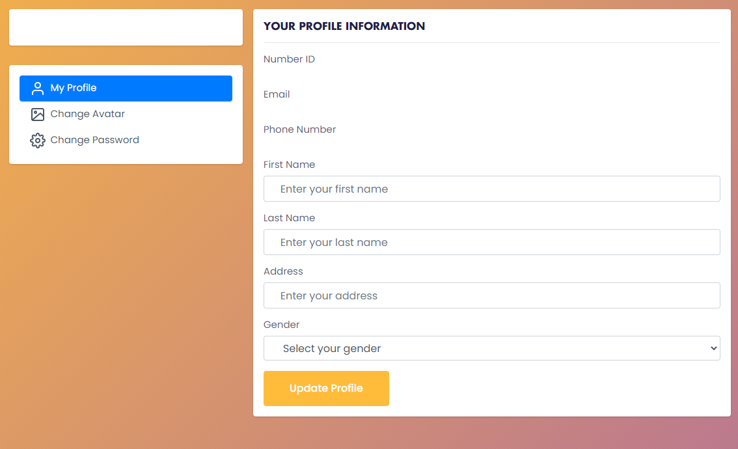Profile setting
3. 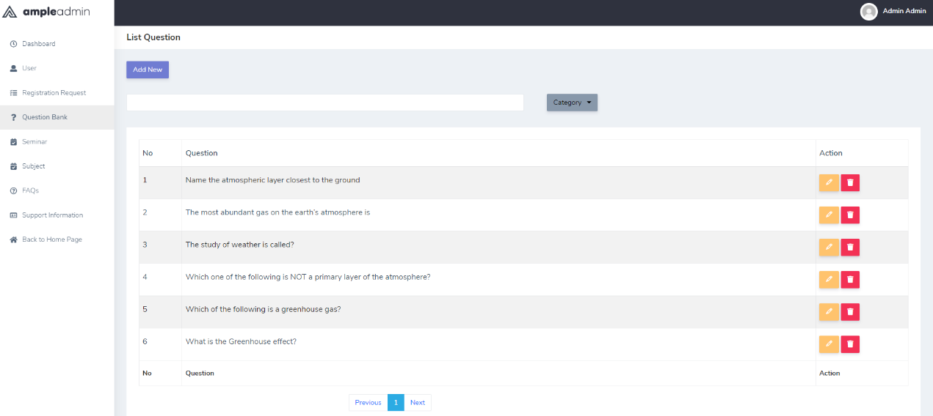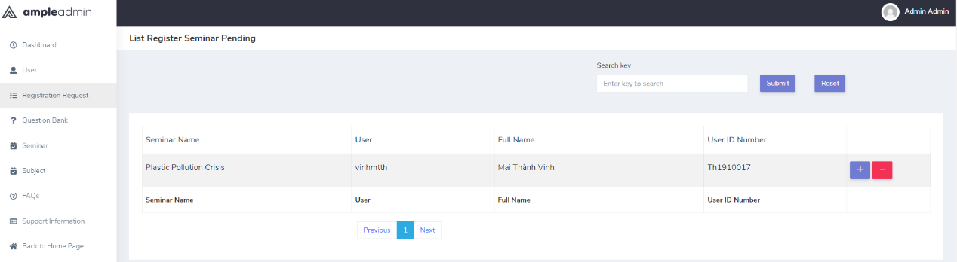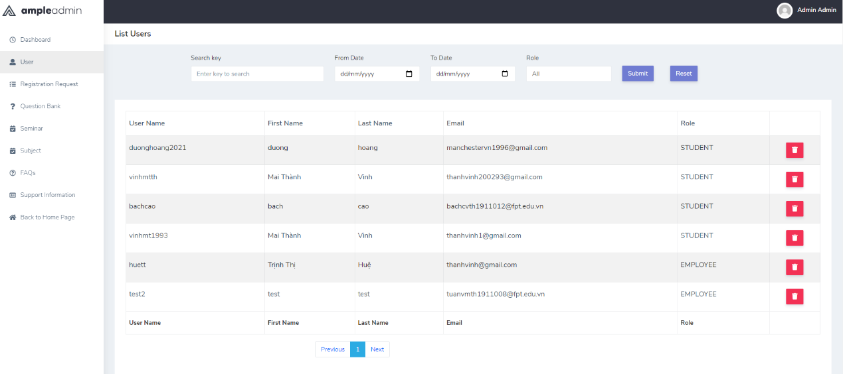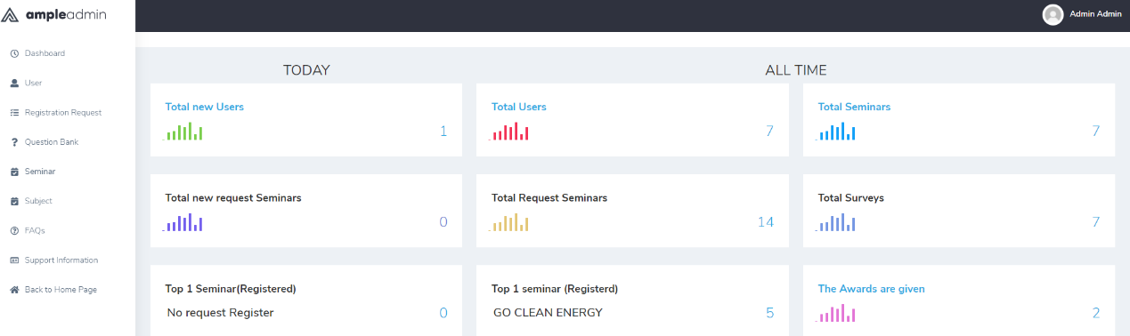Admin dashboard

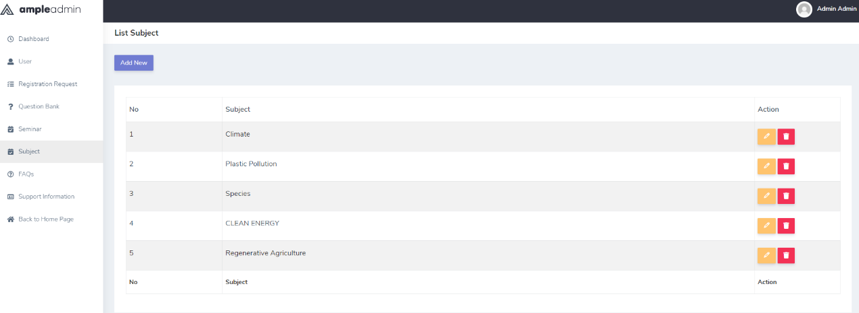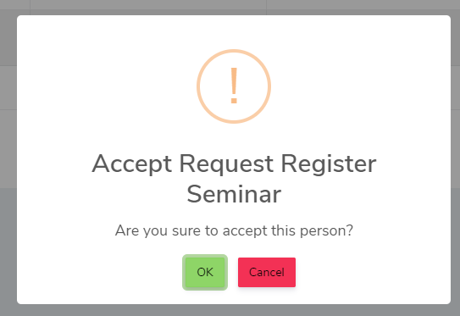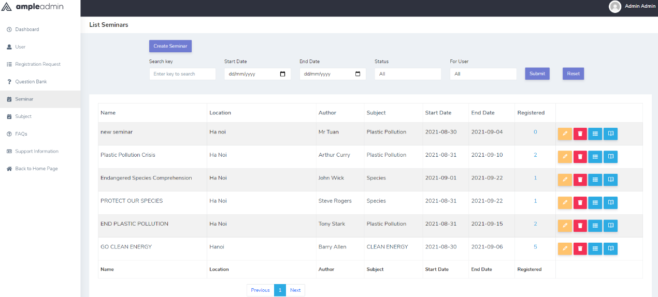

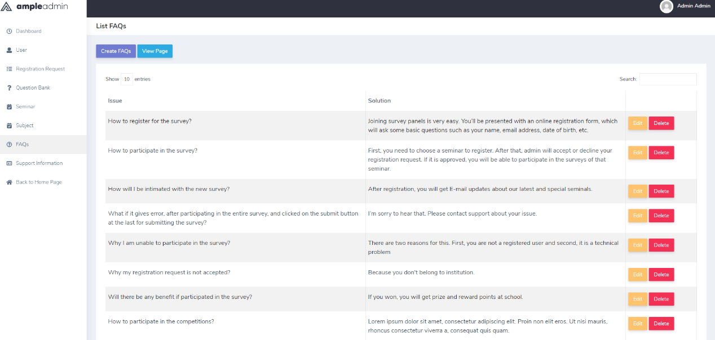

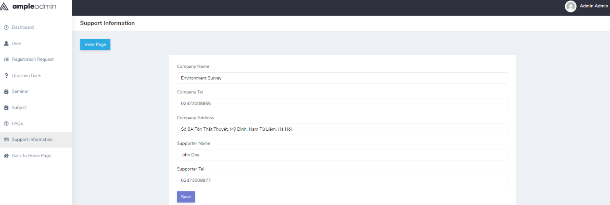

1. 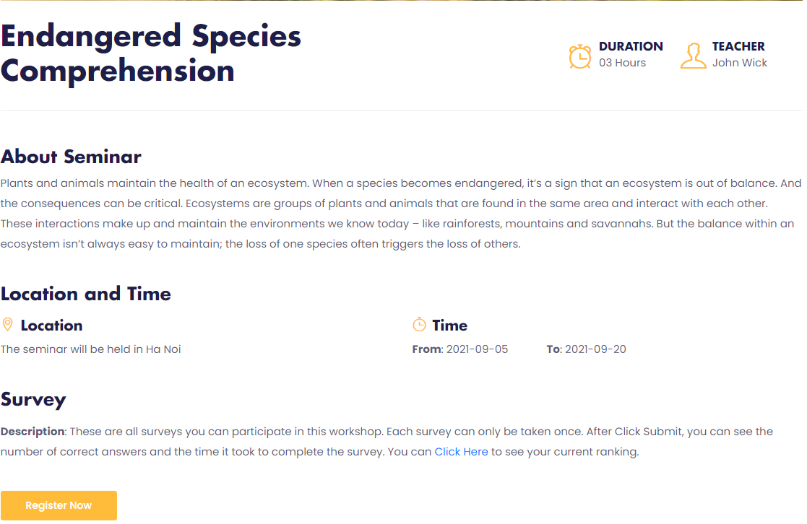Seminar Detail

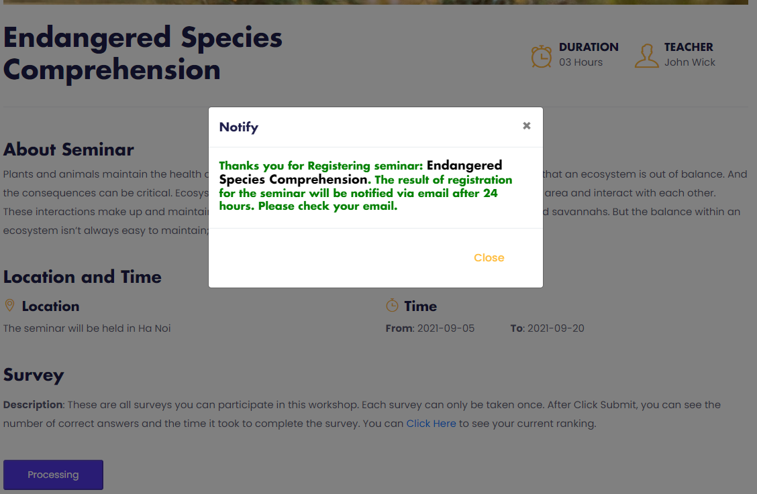

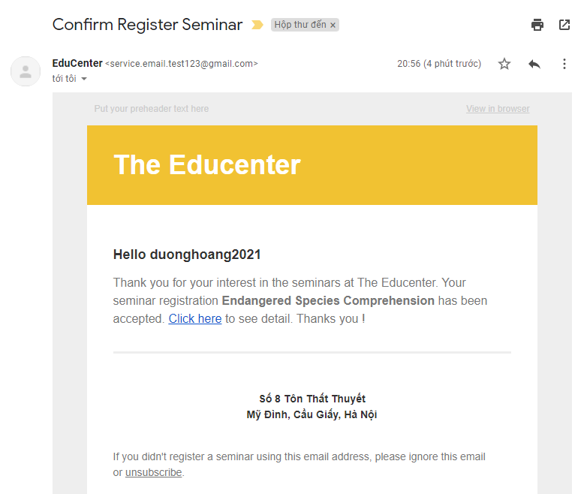

# Management and Project Planning

## Management Approach

*< Briefly describe the management approach that your team selects. Is your team self-managed or managed by one leader? How do you assign tasks to team members? How often do you meet? What do you do during meetings? Etc.>*

## Project Plan

*<The detailed project plan is put here. You can use WBS Excel sheet, Sprint Backlog (see Sprint Backlog_Template.xls), Task sheet, Gantt chart, etc. to present your team’s plan. You can capture the Gantt chart in PMS if you use it to plan your project>*

## Task Sheet

*<Write down the tasks in Task Sheet-compatible format, this Task Sheet works as the activity report of the project or the plan of the project (not recommended); see eProject Guide for detailed Task Sheet>*

## Meeting Minutes (Optional)

*<Put all minutes of your team meetings here>*

# Checklists

## Check List of Validation

*< Put the checklist here; describe how it is used and the resulted checklist>*

## Submission Checklist

*< Put the checklist here; describe how it is used and the resulted checklist>*

# Screenshots

*<Capture some intuitive and main screens of the software and put them here>*

# Coding Convention

*<Provide the coding convention for your team. If you simply want to use the existing code standard(s) such as ‘Java Code Convention’, you can refer to it\them by name or URL>*

# User Guide

*<Provide guidelines for using the system >*

# Other Concerns<Optional>

*<If you have any other information you want to add to this document, place it here. This could include thoughts on the eProject, improvements, etc.>*

# Appendix

## Glossary [Optional]

*<Place all definitions or abbreviation used in this document >*

## References [Optional]

*<Place all referenced materials used in this document >*

## Others<Optional>